Mu Delta – Rush Application Form Winter 2021

Instructions: Please fill out all fields and email to mudeltaucsb@gmail.com no later than January 14, 2021

- Name:
- Email:
- Phone Number:
- Current GPA (indicate whether it is from High School or UCSB or other):
- Current year (First, Second, Third, Fourth, or transfer):
- Your field/major of study:
- Will you be in Isla Vista/Goleta/Santa Barbara area for Spring 2021?
- Why do you want to go to medical school and/or the pre-health route? (200 words MAX):
- Use this space to provide us with any additional information you would like us to know. (optional):
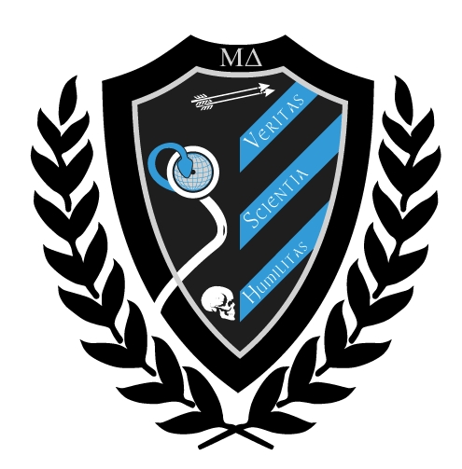
- Please attach a picture to this email for us to identify you (This picture is used only for identification and record keeping purposes. It will have NO affect on your admission decision.)

